
Statistical Consulting Center
Department of Statistics
Eberly College of Science

Tel: (814) 863-0281
Fax: (814) 863-7114
The Pennsylvania State University
323 Thomas Building
University Park, Pa 16802

July 13, 2014

From: Shenee Norton, Graduate Student Consultant

To: Ms. Abigail Johnson, Sales Analyst
Department of Consumer Studies
Philadelphia, PA

Re: Statistical Analysis of Sales Model

RESEARCH FIELD: Business Economics

PROJECT TITLE: Results of Sales Prediction Model

1.0 - PROJECT DESCRIPTION

Forecasting is a frequently used tool for making short-term and long-term decisions by using historical data to produce estimates for future developments such as profits, expenditures and sales. Particularly in business, forecasting plays a very important role in helping managers prepare for the future in a constantly changing economy.

The goal of this project is to use historical data to predict future sales using a statistical prediction model. The historical data contains observed quarterly values of wage and salary disbursements, employment, building material dealer sales, auto dealer sales, furniture dealer sales and general merchandise dealer sales. These quarterly values span from year 1979 to year 1989. The values to predict are sales for the four quarters in the year 1990. The predicted sales are then compared to the actual sales. The accuracy of the model is measured by determining whether actual sales are within the 95% prediction interval obtained using the predicted sales.

2.0 - DATA

These data are published monthly by the Bureau of Economic Analysis in the statistical section of the Survey of Current Business publication. The data consists of 7 variables and 44 observations. There is one observation of each variable for each quarter starting from the first quarter of 1979 to the last quarter of 1990 (11 years x 4 quarters = 44).

Variable Names:

1. TIME: Quarter, numbered 1 to 44, from 1st quarter 1979 to 4th quarter 1989
2. WASA: National income wage and salary disbursements ($ billions)
3. EMPL: Employees on payrolls of non-agricultural establishments (thousands)
4. BLDG: Building material dealer sales ($ millions)
5. AUTO: Automotive dealer sales ($ millions)
6. FURN: Furniture and home furnishings dealer sales ($ millions)
7. GMER: General merchandise dealer sales ($ millions)

The objective of the prediction model is to predict the dealer sales (for each building material, auto, furniture and general merchandise) that will occur in the next four quarters (i.e. year 1990). Accordingly, the response variables in the model are BLDG, AUTO, FURN and GMER. The predictor variables are TIME, WASA and EMPL. Lag (past) values of sales can also be used a predictors. All of the variables are quantitative. Some basic characteristics of the variables can be found in Table 2.1.

Table 2.1 Descriptive Statistics of WASA, EMPL, BLDG, AUTO, FURN and GMER
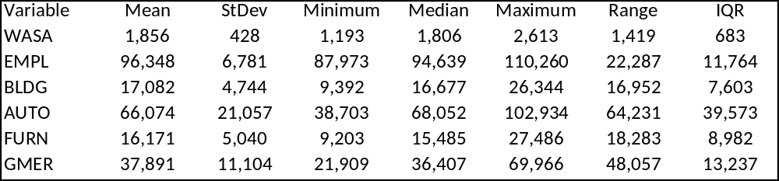

3.0 - EXPLORATORY DATA ANALYSIS (EDA)

3.1 - Data Visualization

The distribution of each variable is displayed in the boxplots contained in Figures 3.1a – 3.1c. The box represents the interquartile range (i.e. mid-range values) of the variable and is divided by a horizontal line which represents the median value. Each box has whiskers that extend outward to the minimum and maximum value of the variable. If existing, outliers are represented by asterisks. An outlier is a data value that is noticeably distant from the other values. Unfortunately, outliers can potentially reduce the reliability of a statistical model.

Figure 3.1a Boxplot of WASA
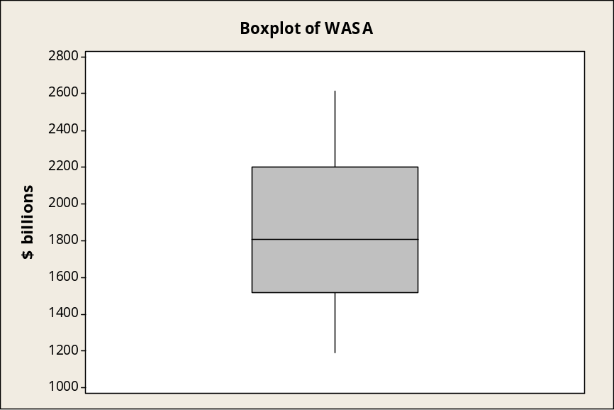
Figure 3.1b Boxplot of EMPL
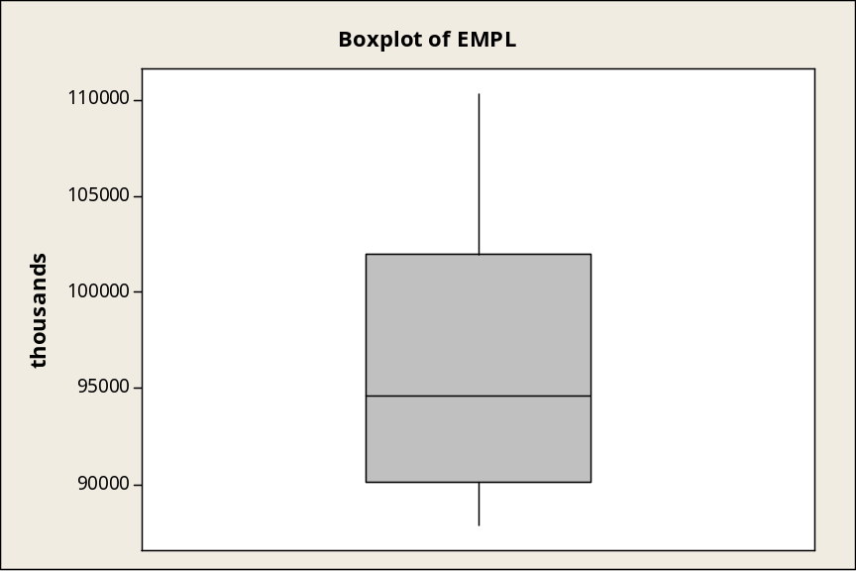

Figure 3.1c Boxplot of BLDG, AUTO, FURN and GMER
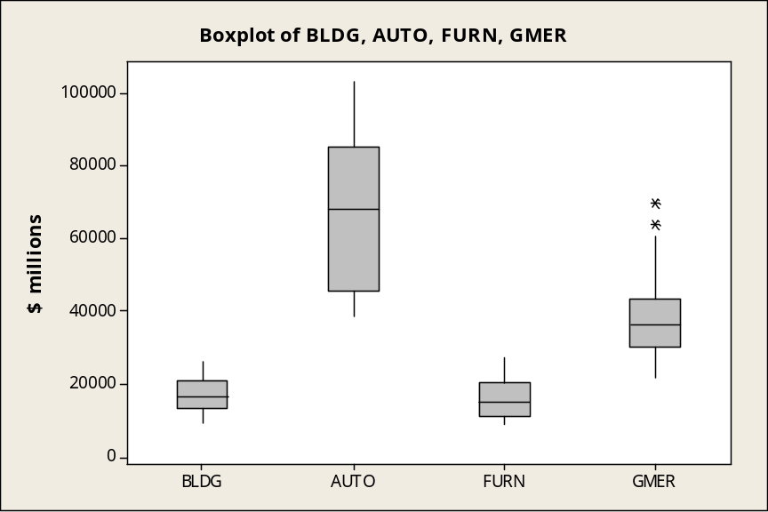

Figure 3.1c compares the distributions among the dealer sales. It is clear that automotive dealer sales has a much wider spread of values that the other sales. Building and furniture dealer sales have a similar range of sales. General merchandise dealer sales have two outliers. Since the outliers don’t appear to be flagrantly distant and removing them will reduce the number of observations available for statistical analysis, they will remain in the data.

3.2 – Examining Linear Relationships

In addition to the distribution of the variables, whether or not the variables have a linear relationship with TIME is also of interest since it will influence what is done with the data. The scatter plots in Figure 3.2 show that the variables have a linear relationship with TIME.

Figure 3.2 Scatterplot of WASA, EMPL, BLDG, AUTO, FURN and GMER versus Time
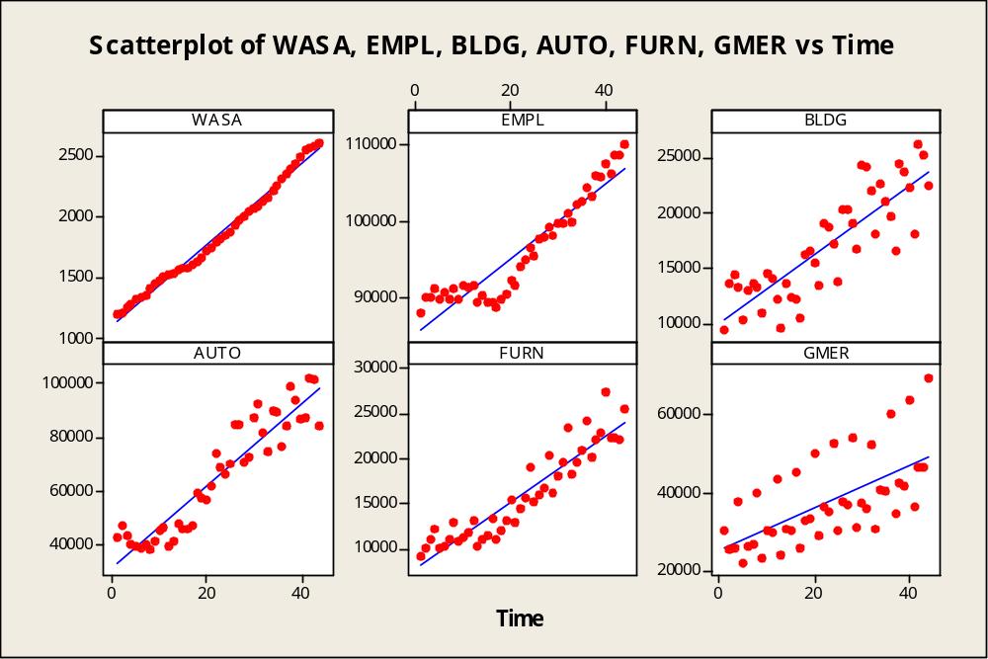

All the variables appear to have a strong positive linear relationship with TIME. This means that the variables increase as time goes on. WASA appears to have the strongest relationship and GMER has the weakest. It is also possible that the variables are strongly linearly correlated with each other (multicollinearity). The presence of multicollinearity is problematic because it can cause the variable coefficient estimates to change erratically when a small change to the model or the data is made. This makes the model unstable. Multicollinearity will be assessed after the final form of the data series has been selected.

3.3 – Time Series Analysis Data Preparation

As stated earlier, each variable is observed quarterly -- at equally spaced successive points in time. Thus, the pairing of each variable with TIME creates a times series. So, the EDA includes creating a time series plot of each variable and noting the characteristics of the series. The time series model assumptions require that the time series be stationary. Stationary means that the time series has neither trend nor non-constant variance. Since the data is quarterly, the time series are expected to have seasonality. Seasonality occurs when the time series exhibits a pattern that repeats every period (which is every four quarters in this case). The time series are also expected to have an upward trend (as seen in the scatter plots of Figure 3.2).

Figure 3.3a WASA – The time series plot shows trend since the values steadily increase. The values seem to dip slightly every second quarter, so there may also be seasonality as well.
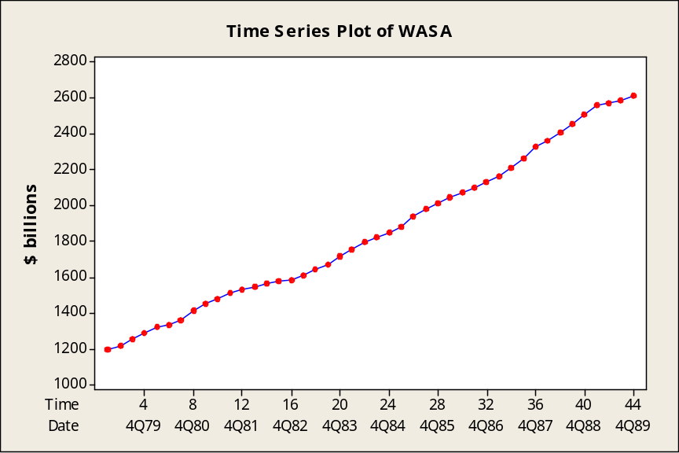

Figure 3.3b EMPL –The time series plot seems stationary until the first quarter of 1983, then the values trend upward. The values appear the have a pattern, so seasonality may be present.
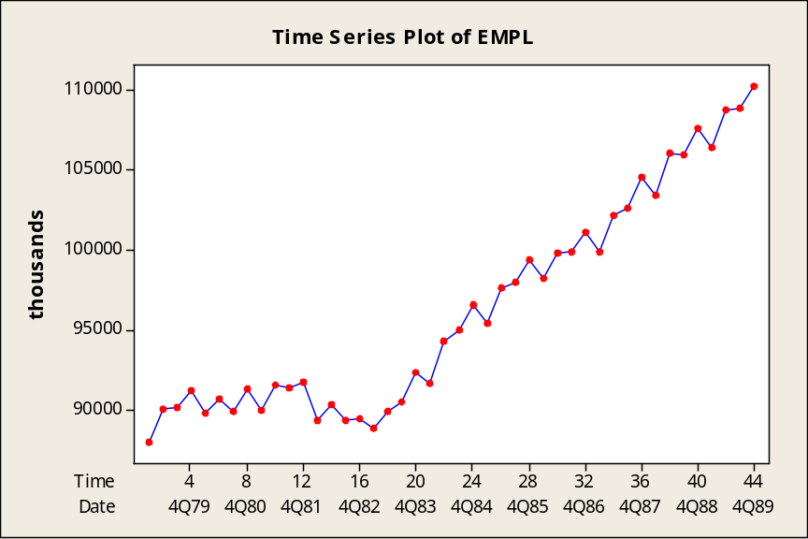

Figure 3.3c BLDG –The time series plot seems stationary until the first quarter of 1983, then sales trend upward. The values appear the have a pattern that repeats every four quarters, so seasonality may be present.
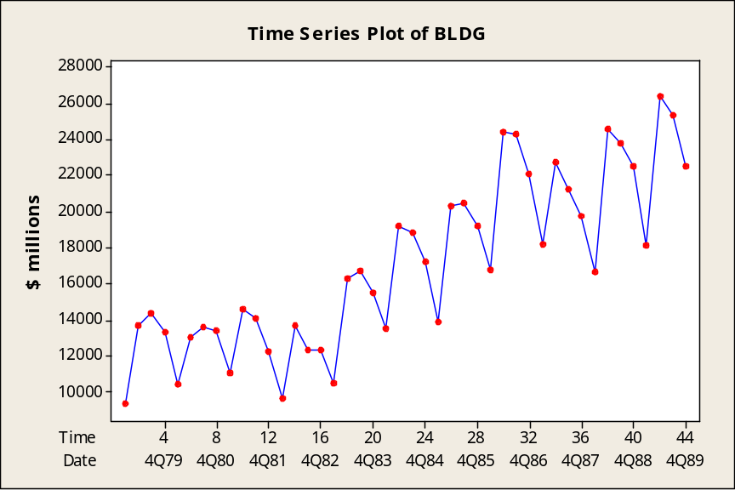

Figure 3.3d AUTO –The time series plot seems stationary until the first quarter of 1983, then sales trend upward. The values appear the have a pattern that repeats every four quarters, so seasonality may be present. The variance of sales increases with time.
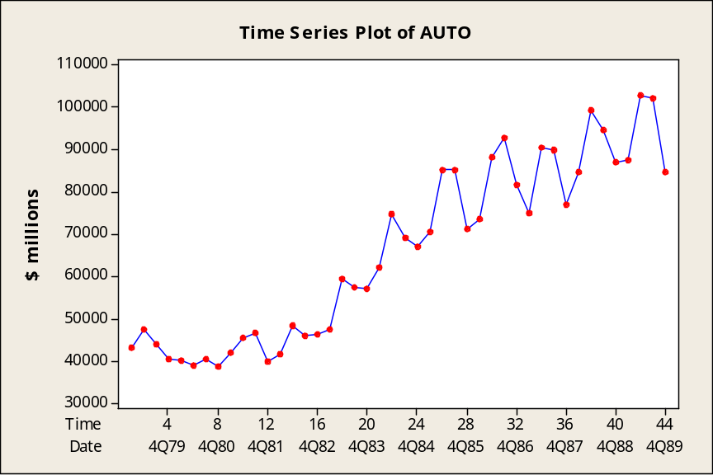

Figure 3.3e FURN –The time series plot shows that sales generally trend upward. Sales appear to have a pattern that repeats every four quarters, so seasonality may be present. The variance of sales increases with time.
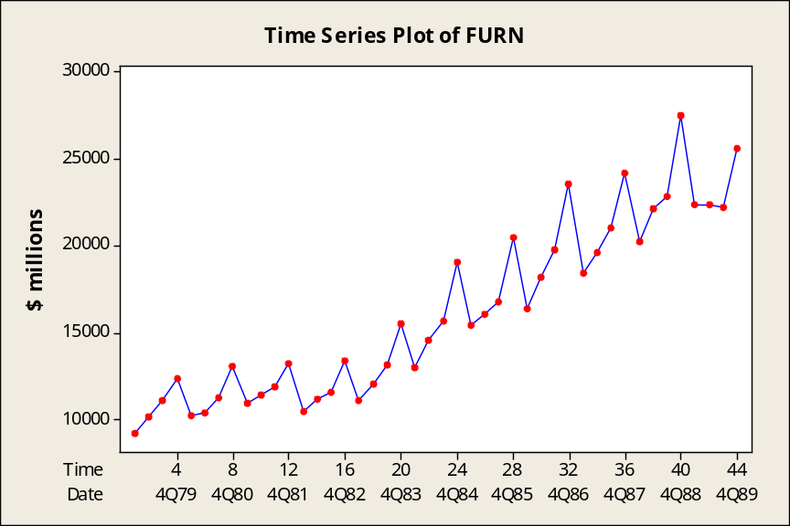

Figure 3.3f GMER –The time series plot shows that sales generally trend upward. Sales appear to have a strong pattern that repeats every four quarters, so seasonality is likely present. The variance of sales considerably increases with time.
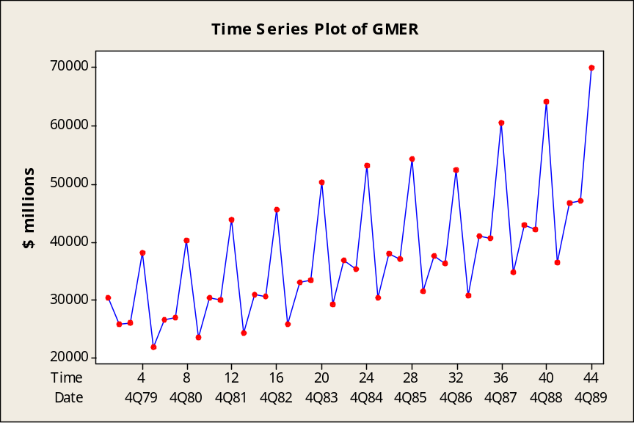

All of the plots in Figures 3.3a - 3.3f showed trend, so each series was detrended using linear regression. The detrending process was performed by regressing each variable on time and then using the regression residuals instead of the original data series. Next, a fourth difference was applied to the detrended series to account for seasonality that repeats every four quarters.

Now that each time series is stationary, they can be fit to an appropriate time series model. Figures 3.4a - 3.4f illustrate the detrended, stationary time series.

Figure 3.4a Time series plot of DTWASA
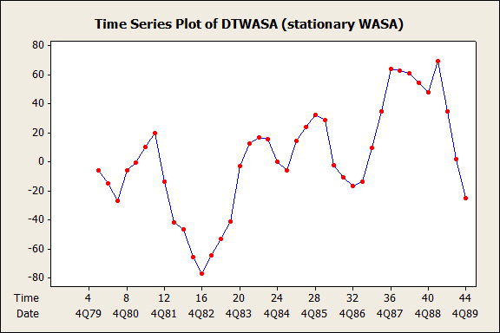

Figure 3.4b Time series plot of DTEMPL
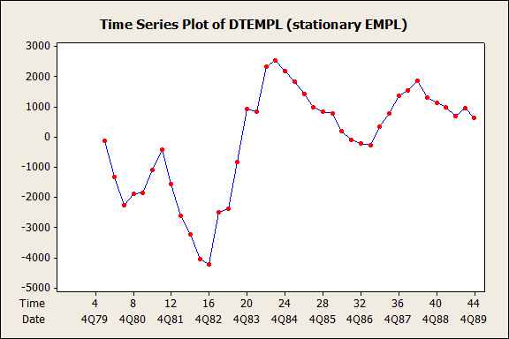

Figure 3.4c Time series plot of DTBLDG
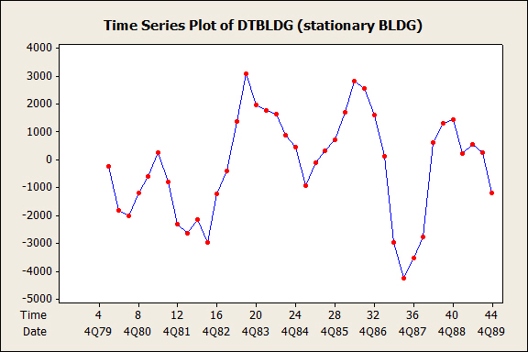
Figure 3.4d Time series plot of DTAUTO
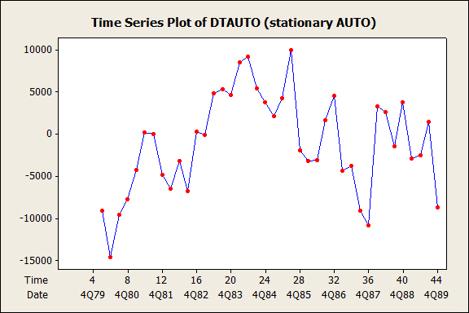

Figure 3.4e Time series plot of DTFURN
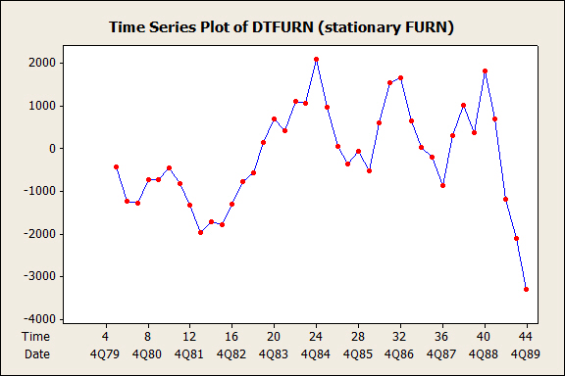

Figure 3.4f Time series plot of DTGMER
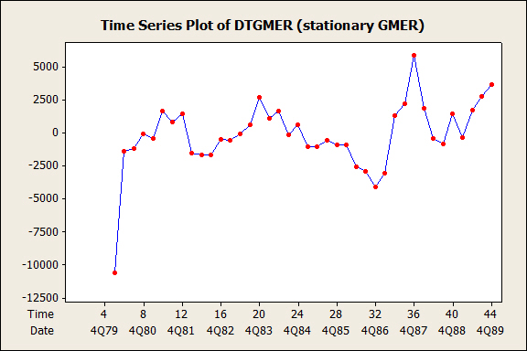

Further, the new stationary series can be tested for multicollinearity by using variance inflation factors (VIF). A VIF measures the severity of multicollinearity in a regression model. VIFs smaller than 5 indicate moderate multicollinearity. Table 3.3 lists the VIFs for each times series when regressed on all the other time series. The largest VIF is 3.6, thus multicollinearity is not a concern.

Table 3.3 Variance inflation factors for each multiple regression model among the time series
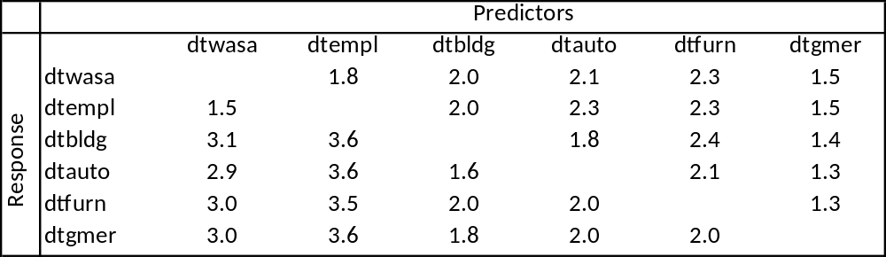

4.0 –STATISTICAL ANALYSIS

The time series were fit to a p-lag vector autoregressive (VAR(p)) model using the ar.ols function of the R 3.1 statistical software. The model allows use of a multivariate time series. The form is such that each variable is a linear function of past values of itself and past values of the other variables. The ar.ols function uses ordinary least squares to produce a separate linear model for each time series. The order of the model is determined by the number of lags needed to obtain a reasonable fit. The model selected is a VAR(3) model. The number three indicates that three lag values are used in the model. The form of the VAR(3) model for each of the n = 6 time series (DTWASA, DTEMPL, DTBLDG, DTAUTO, DTFURN and DTGMER) can be written as follows:

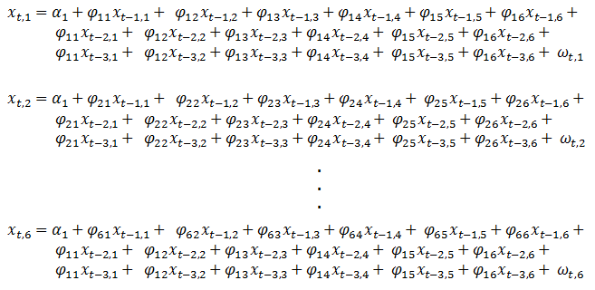

Where χ is the time series, α is the intercept, φ is the coefficient estimate for each lag value and ω is the uncorrelated error term. The ar.ols function returns a model for every time series used in the function even though we are only interested in modelling four of the time series (DTBLDG, DTAUTO, DTFURN and DTGMER).

The appropriateness of the model is checked by examining the autocorrelation function (ACF) plot of the residuals of each variable in the model. An ACF plot with no significant lags is desirable since it indicates that the residuals are uncorrelated. The ACF plots (see Figures 4.1a – 4.1f) of the VAR(3) model were acceptable.

Figure 4.1a ACF for DTWASA
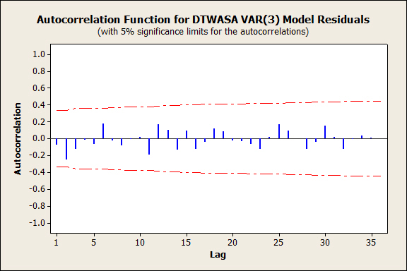

Figure 4.1b ACF for DTEMPL
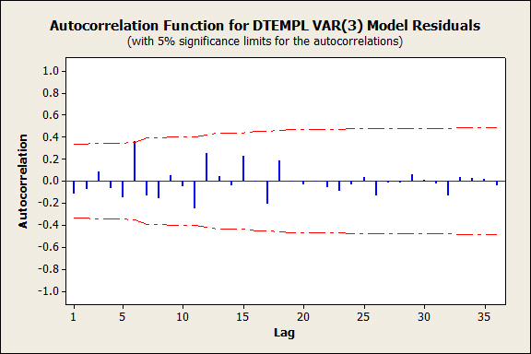

Figure 4.1c ACF for DTBLDG
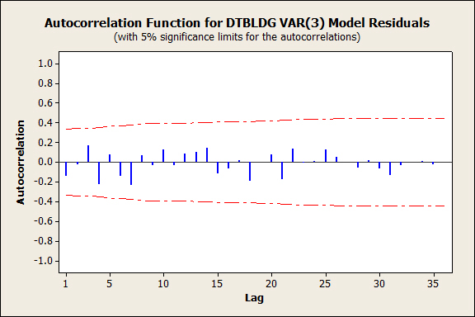

Figure 4.1d ACF for DTAUTO
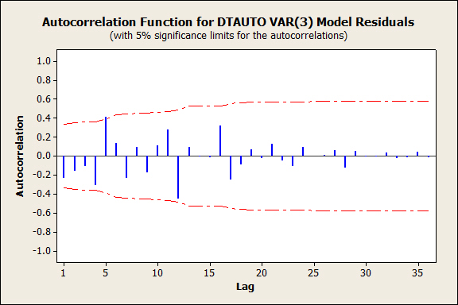

Figure 4.1e ACF for DTFURN
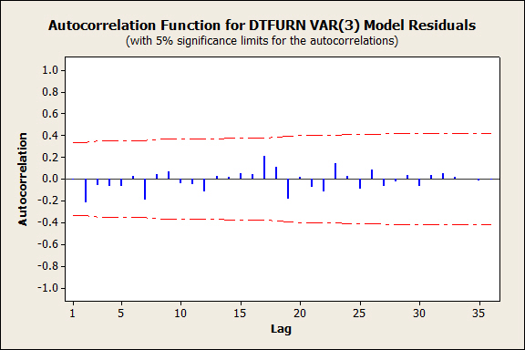

Figure 4.1f ACF for DTGMER
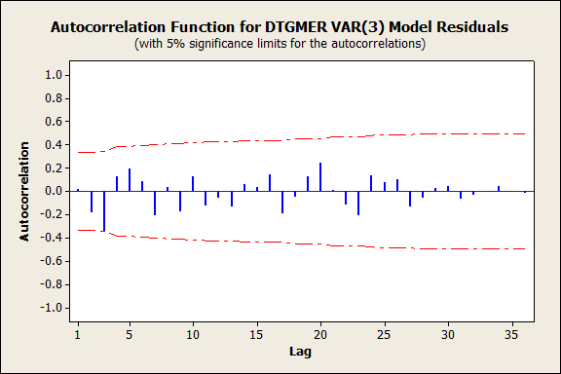

Next, the R prediction function was used to predict the next four values for each variable. The corresponding standard errors and prediction intervals had to be calculated manually since they are not yet implemented in R for multivariate models. The ARMAto MA function was used to obtain the psi weights needed for calculating the standard errors. The VAR(3) model intercepts and variable coefficient estimates can be found in Table 4.1.

Table 4.1 VAR(3) intercepts and coefficient estimates
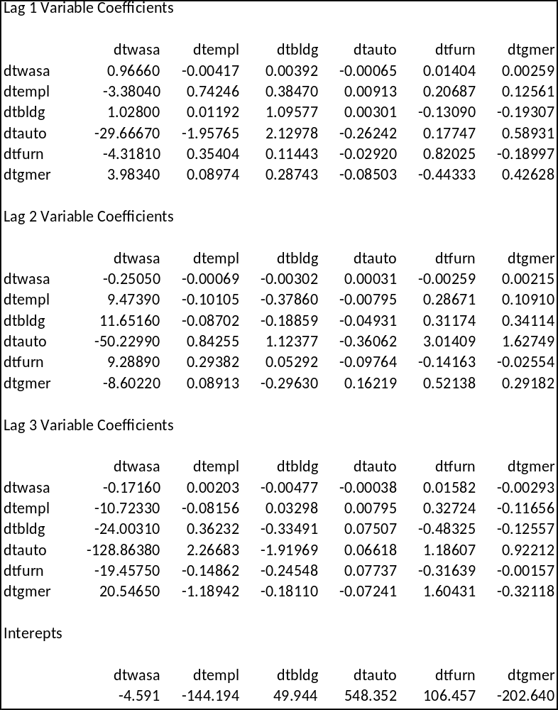

5.0 – RESULTS

The prediction model’s accuracy was measured by its ability to provide an interval in which the actual dealer sales falls. Overall, actual dealer sales were found to be within the prediction interval about 63% of the time. Individually, the model’s accuracy was 25%, 100%, 50% and 75% for building material dealer sales, automotive dealer sales, furniture dealer sales and general merchandise dealer sales, respectively. A summary of the results is given in Table 5.1.

Table 5.1 VAR(3) model results
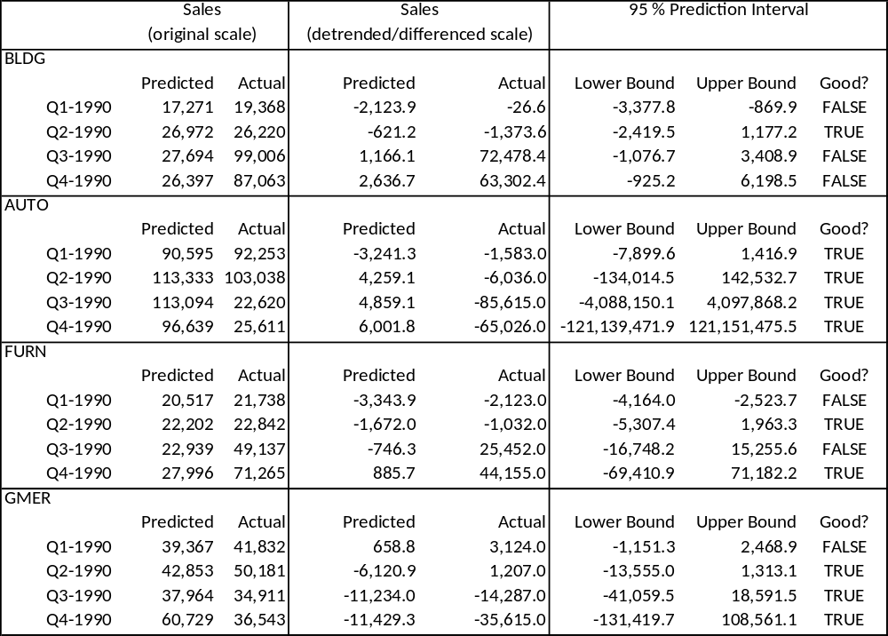

6.0 - CONSIDERATIONS

As a rule of thumb, time series data should have at least 50 observations to make sure that there is enough information to model the data correctly. In this case we started with 44 observations and lost 4 due to seasonal differencing. So the model was fitted to series having only 40 observations. It is advisable that future studies have at least 50 observations.

Along with evaluating how well a particular model predicts dealer sales, the width of the prediction interval needs to be considered to make sure it is realistic for the contextual situation at hand. A prediction interval can be unrealistically wide or unrealistically narrow, thus it may not have a meaningful or useful interpretation.

I want to personally thank you for the opportunity to work on this project. Please don’t hesitate to contact me if you have any further questions.

7.0 - RESOURCES

1: Basics of Time Series Models - https://onlinecourses.science.psu.edu/stat510/node/41

2: Seasonal Time Series Models - https://onlinecourses.science.psu.edu/stat510/node/50

3: Vector Autoregressive Models - https://onlinecourses.science.psu.edu/stat510/node/79

4: R function ar.ols - http://stat.ethz.ch/R-manual/R-patched/library/stats/html/ar.ols.html

5: Linear Trend Models - http://people.duke.edu/~rnau/411trend.htm

6.0 - Appendix

Data:

Table 1A Original data series
TIME | WASA | EMPL | BLDG | AUTO | FURN | GMER
1 | 1193.3 | 87973 | 9392 | 42960 | 9203 | 30363
2 | 1217.3 | 90021 | 13637 | 47516 | 10174 | 25812
3 | 1254.4 | 90120 | 14392 | 43888 | 11078 | 26026
4 | 1284.7 | 91180 | 13301 | 40298 | 12334 | 38081
5 | 1319.8 | 89832 | 10411 | 40016 | 10228 | 21909
6 | 1335.1 | 90668 | 13057 | 39073 | 10394 | 26615
7 | 1360.1 | 89850 | 13621 | 40484 | 11246 | 27039
8 | 1411.6 | 91276 | 13354 | 38703 | 13071 | 40170
9 | 1451.7 | 89964 | 11056 | 41919 | 10954 | 23641
10 | 1478.1 | 91566 | 14559 | 45398 | 11410 | 30477
11 | 1512.6 | 91405 | 14067 | 46635 | 11892 | 30065
12 | 1530.6 | 91691 | 12286 | 39970 | 13204 | 43805
13 | 1542.7 | 89341 | 9658 | 41554 | 10439 | 24256
14 | 1563.9 | 90310 | 13659 | 48384 | 11148 | 30976
15 | 1579.8 | 89324 | 12351 | 46041 | 11556 | 30579
16 | 1586 | 89436 | 12307 | 46411 | 13370 | 45471
17 | 1610.7 | 88815 | 10508 | 47558 | 11114 | 25891
18 | 1643.5 | 89920 | 16287 | 59342 | 12043 | 33050
19 | 1671.3 | 90480 | 16697 | 57487 | 13165 | 33385
20 | 1715.4 | 92367 | 15523 | 57165 | 15534 | 50311
21 | 1755.8 | 91637 | 13540 | 62200 | 13002 | 29177
22 | 1793.1 | 94256 | 19190 | 74678 | 14602 | 36855
23 | 1819.5 | 95021 | 18827 | 69074 | 15684 | 35418
24 | 1847.7 | 96547 | 17215 | 67030 | 19088 | 53126
25 | 1882.7 | 95450 | 13848 | 70453 | 15436 | 30325
26 | 1939.8 | 97657 | 20319 | 85102 | 16117 | 37977
27 | 1976 | 97985 | 20403 | 85142 | 16782 | 37028
28 | 2012.8 | 99383 | 19179 | 71203 | 20491 | 54369
29 | 2044.1 | 98213 | 16790 | 73380 | 16383 | 31594
30 | 2069.8 | 99850 | 24400 | 88139 | 18180 | 37617
31 | 2097.9 | 99877 | 24215 | 92899 | 19782 | 36297
32 | 2128.4 | 101169 | 22042 | 81838 | 23605 | 52457
33 | 2163.2 | 99922 | 18182 | 75122 | 18483 | 30718
34 | 2211.9 | 102186 | 22670 | 90515 | 19659 | 41090
35 | 2265.1 | 102657 | 21204 | 89907 | 21042 | 40706
36 | 2325 | 104522 | 19746 | 77163 | 24203 | 60491
37 | 2358.7 | 103445 | 16656 | 84508 | 20242 | 34723
38 | 2405.6 | 106050 | 24552 | 99279 | 22143 | 42871
39 | 2452.2 | 105963 | 23775 | 94556 | 22870 | 42072
40 | 2505.1 | 107644 | 22449 | 87039 | 27486 | 64101
41 | 2560.7 | 106425 | 18145 | 87696 | 22399 | 36516
42 | 2572.9 | 108741 | 26344 | 102934 | 22412 | 46782
43 | 2586.6 | 108897 | 25278 | 102095 | 22223 | 47006
44 | 2612.7 | 110260 | 22511 | 84497 | 25648 | 69966

Table A2 Actual values for 1990
Values for 1990:
 | Quarter |  |  | BDLG | AUTO | FURN | GMER
 | 1 |  |  | 19368 | 92253 | 21738 | 41832
 | 2 |  |  | 26220 | 103038 | 22842 | 50181
 | 3 |  |  | 99006 | 22620 | 49137 | 34911
 | 4 |  |  | 87063 | 25611 | 71265 | 36543

Table A3 Standard errors for each predicted quarter in 1990
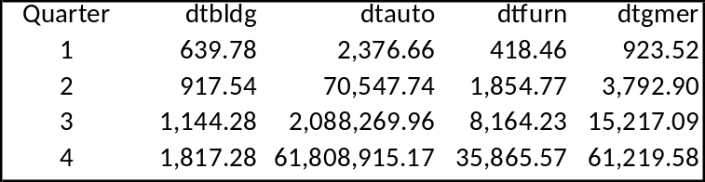

R Program Code and Output:

> setwd("C:/Users/Shenee/Documents/STAT581")
>
> sales <- read.csv("sales.csv")
> attach(sales)
> source("itall.R")
itall has been installed
> library(car)
>
> # Designate data as a time series
>
> wasa = ts(wasa)
> empl = ts(empl)
> bldg = ts(bldg)
> auto = ts(auto)
> furn = ts(furn)
> gmer = ts(gmer)
>
> # Linear regressions between
> # each variable and time (de-trending)
>
> wasa.lm = lm (wasa~time(wasa))
> empl.lm = lm (empl~time(empl))
> bldg.lm = lm (bldg~time(bldg))
> auto.lm = lm (auto~time(auto))
> furn.lm = lm (furn~time(furn))
> gmer.lm = lm (gmer~time(gmer))
>
> wasa.lm

Call:
lm(formula = wasa ~ time(wasa))

Coefficients:
(Intercept) time(wasa)
1109.48 33.16

> empl.lm

Call:
lm(formula = empl ~ time(empl))

Coefficients:
(Intercept) time(empl)
85206.6 495.2

> bldg.lm

Call:
lm(formula = bldg ~ time(bldg))

Coefficients:
(Intercept) time(bldg)
10053.3 312.4

> auto.lm

Call:
lm(formula = auto ~ time(auto))

Coefficients:
(Intercept) time(auto)
31531 1535

> furn.lm

Call:
lm(formula = furn ~ time(furn))

Coefficients:
(Intercept) time(furn)
7948.0 365.5

> gmer.lm

Call:
lm(formula = gmer ~ time(gmer))

Coefficients:
(Intercept) time(gmer)
25562 548

>
> wasa.res = residuals(wasa.lm)
> empl.res = residuals(empl.lm)
> bldg.res = residuals(bldg.lm)
> auto.res = residuals(auto.lm)
> furn.res = residuals(furn.lm)
> gmer.res = residuals(gmer.lm)
>
> # Exploratory Data Analysis
>
> par(mfrow=c(3,1)) # plot time series
> plot(wasa, type="o", xlab=NULL, main="wasa")
> plot(wasa.res, type="o", xlab="Time", main="detrended")
> plot(diff(wasa.res,4), type="o", xlab="Time", main="fourth difference(detrended)")
>
> plot(empl, type="o", xlab=NULL, main="empl")
> plot(empl.res, type="o", xlab=NULL, main="detrended")
> plot(diff(empl.res,4), type="o", xlab="Time", main="fourth difference(detrended)")
>
> plot(bldg, type="o", xlab=NULL, main="bldg")
> plot(bldg.res, type="o", xlab=NULL, main="detrended")
> plot(diff(bldg.res,4), type="o", xlab="Time", main="fourth difference(detrended)")
>
> plot(auto, type="o", xlab=NULL, main="auto")
> plot(auto.res, type="o", xlab=NULL, main="detrended")
> plot(diff(auto.res,4), type="o", xlab="Time", main="fourth difference(detrended)")
>
> plot(furn, type="o", xlab=NULL, main="furn")
> plot(furn.res, type="o", xlab=NULL, main="detrended")
> plot(diff(furn.res,4), type="o", xlab="Time", main="fourth difference(detrended)")
>
> plot(gmer, type="o", xlab=NULL, main="gmer")
> plot(gmer.res, type="o", xlab=NULL, main="detrended")
> plot(diff(gmer.res,4), type="o", xlab="Time", main="fourth difference(detrended)")
>
> # Identify AR order
>
> par(mfrow=c(3,1)) # plot ACFs
> acf(wasa, 40, xlab="", main="wasa")
> acf(wasa.res,40, xlab="", main="detrended")
> acf(diff(wasa.res,4),40, main="fourth difference") #AR(3)
>
> acf(empl, 40, xlab="", main="empl")
> acf(empl.res,40, xlab="", main="detrended")
> acf(diff(empl.res,4),40, main="fourth difference") #AR(3)
>
> acf(bldg, 40, xlab="", main="bldg")
> acf(bldg.res,40, xlab="", main="detrended")
> acf(diff(bldg.res,4),40, main="fourth difference") #AR(3)
>
> acf(auto, 40, xlab="", main="auto")
> acf(auto.res,40, xlab="", main="detrended")
> acf(diff(auto.res,4),40, main="fourth difference") #AR(3)
>
> acf(furn, 40, xlab="", main="furn")
> acf(furn.res,40, xlab="", main="detrended")
> acf(diff(furn.res,4),40, main="fourth difference") #AR(3)
>
> acf(gmer, 40, xlab="", main="gmer")
> acf(gmer.res,40, xlab="", main="detrended")
> acf(diff(gmer.res,4),40, main="fourth difference") #AR(2)
>
> # Store the differenced residuals from each regression
>
> dtwasa = diff(residuals( wasa.lm),4)
> dtempl = diff(residuals( empl.lm),4)
> dtbldg = diff(residuals( bldg.lm),4)
> dtauto = diff(residuals( auto.lm),4)
> dtfurn = diff(residuals( furn.lm),4)
> dtgmer = diff(residuals( gmer.lm),4)
>
> dtwasa
5 6 7 8 9 10
-6.1576744 -14.8576744 -26.9576744 -5.7576744 -0.7576744 10.3423256
11 12 13 14 15 16
19.8423256 -13.6576744 -41.6576744 -46.8576744 -65.4576744 -77.2576744
17 18 19 20 21 22
-64.6576744 -53.0576744 -41.1576744 -3.2576744 12.4423256 16.9423256
23 24 25 26 27 28
15.5423256 -0.3576744 -5.7576744 14.0423256 23.8423256 32.4423256
29 30 31 32 33 34
28.7423256 -2.6576744 -10.7576744 -17.0576744 -13.5576744 9.4423256
35 36 37 38 39 40
34.5423256 63.9423256 62.8423256 61.0423256 54.4423256 47.4423256
41 42 43 44
69.3423256 34.6423256 1.7423256 -25.0576744
> dtempl
5 6 7 8 9 10
-121.63312 -1333.63312 -2250.63312 -1884.63312 -1848.63312 -1082.63312
11 12 13 14 15 16
-425.63312 -1565.63312 -2603.63312 -3236.63312 -4061.63312 -4235.63312
17 18 19 20 21 22
-2506.63312 -2370.63312 -824.63312 950.36688 841.36688 2355.36688
23 24 25 26 27 28
2560.36688 2199.36688 1832.36688 1420.36688 983.36688 855.36688
29 30 31 32 33 34
782.36688 212.36688 -88.63312 -194.63312 -271.63312 355.36688
35 36 37 38 39 40
799.36688 1372.36688 1542.36688 1883.36688 1325.36688 1141.36688
41 42 43 44
999.36688 710.36688 953.36688 635.36688
> dtbldg
5 6 7 8 9 10 11 12
-230.518 -1829.518 -2020.518 -1196.518 -604.518 252.482 -803.518 -2317.518
13 14 15 16 17 18 19 20
-2647.518 -2149.518 -2965.518 -1228.518 -399.518 1378.482 3096.482 1966.482
21 22 23 24 25 26 27 28
1782.482 1653.482 880.482 442.482 -941.518 -120.518 326.482 714.482
29 30 31 32 33 34 35 36
1692.482 2831.482 2562.482 1613.482 142.482 -2979.518 -4260.518 -3545.518
37 38 39 40 41 42 43 44
-2775.518 632.482 1321.482 1453.482 239.482 542.482 253.482 -1187.518
> dtauto
5 6 7 8 9 10
-9084.93672 -14583.93672 -9544.93672 -7735.93672 -4237.93672 184.06328
11 12 13 14 15 16
10.06328 -4873.93672 -6505.93672 -3154.93672 -6734.93672 300.06328
17 18 19 20 21 22
-136.93672 4817.06328 5305.06328 4613.06328 8501.06328 9195.06328
23 24 25 26 27 28
5446.06328 3724.06328 2112.06328 4283.06328 9927.06328 -1967.93672
29 30 31 32 33 34
-3213.93672 -3103.93672 1616.06328 4494.06328 -4398.93672 -3764.93672
35 36 37 38 39 40
-9132.93672 -10815.93672 3245.06328 2623.06328 -1491.93672 3735.06328
41 42 43 44
-2952.93672 -2485.93672 1398.06328 -8682.93672
> dtfurn
5 6 7 8 9 10
-436.83932 -1241.83932 -1293.83932 -724.83932 -735.83932 -445.83932
11 12 13 14 15 16
-815.83932 -1328.83932 -1976.83932 -1723.83932 -1797.83932 -1295.83932
17 18 19 20 21 22
-786.83932 -566.83932 147.16068 702.16068 426.16068 1097.16068
23 24 25 26 27 28
1057.16068 2092.16068 972.16068 53.16068 -363.83932 -58.83932
29 30 31 32 33 34
-514.83932 601.16068 1538.16068 1652.16068 638.16068 17.16068
35 36 37 38 39 40
-201.83932 -863.83932 297.16068 1022.16068 366.16068 1821.16068
41 42 43 44
695.16068 -1192.83932 -2108.83932 -3299.83932
> dtgmer
5 6 7 8 9 10
-10645.8658 -1388.8658 -1178.8658 -102.8658 -459.8658 1670.1342
11 12 13 14 15 16
834.1342 1443.1342 -1576.8658 -1692.8658 -1677.8658 -525.8658
17 18 19 20 21 22
-556.8658 -117.8658 614.1342 2648.1342 1094.1342 1613.1342
23 24 25 26 27 28
-158.8658 623.1342 -1043.8658 -1069.8658 -581.8658 -948.8658
29 30 31 32 33 34
-922.8658 -2551.8658 -2922.8658 -4103.8658 -3067.8658 1281.1342
35 36 37 38 39 40
2217.1342 5842.1342 1813.1342 -410.8658 -825.8658 1418.1342
41 42 43 44
-398.8658 1719.1342 2742.1342 3673.1342
>
> # Check for multicollinearity
>
> vif(lm(dtwasa ~ dtempl + dtbldg + dtauto + dtfurn + dtgmer))
dtempl dtbldg dtauto dtfurn dtgmer
1.825063 1.975895 2.130466 2.332130 1.455447
> vif(lm(dtempl ~ dtwasa + dtbldg + dtauto + dtfurn + dtgmer))
dtwasa dtbldg dtauto dtfurn dtgmer
1.549215 1.950257 2.267401 2.296400 1.481540
> vif(lm(dtbldg ~ dtwasa + dtempl + dtauto + dtfurn + dtgmer))
dtwasa dtempl dtauto dtfurn dtgmer
3.083398 3.585287 1.826056 2.382238 1.400384
> vif(lm(dtauto ~ dtwasa + dtempl + dtbldg + dtfurn + dtgmer))
dtwasa dtempl dtbldg dtfurn dtgmer
2.857248 3.582350 1.569357 2.052312 1.292780
> vif(lm(dtfurn ~ dtwasa + dtempl + dtbldg + dtauto + dtgmer))
dtwasa dtempl dtbldg dtauto dtgmer
2.997556 3.477189 1.962157 1.966910 1.270025
> vif(lm(dtgmer ~ dtwasa + dtempl + dtbldg + dtauto + dtfurn))
dtwasa dtempl dtbldg dtauto dtfurn
2.995226 3.591804 1.846776 1.983738 2.033437
>
> # Estimation of AR(1) model
>
> fitvar1 = ar.ols(cbind(dtwasa, dtempl, dtbldg, dtauto, dtfurn, dtgmer), order = 1)
> fitvar1

Call:
ar.ols(x = cbind(dtwasa, dtempl, dtbldg, dtauto, dtfurn, dtgmer), order.max = 1)

$ar
, , 1

dtwasa dtempl dtbldg dtauto dtfurn dtgmer
dtwasa 0.7712 -0.001431 -0.002945 3.367e-05 0.01182 0.001695
dtempl -0.7412 0.744412 0.063565 2.379e-02 0.21190 0.137747
dtbldg 13.8847 -0.324752 0.778510 7.232e-02 -0.12385 0.025189
dtauto -31.9814 -0.130278 0.786198 3.181e-01 1.04854 0.920572
dtfurn -0.7856 -0.061745 0.091607 -3.407e-03 0.86440 0.050824
dtgmer -0.5963 0.315851 -0.026267 -3.016e-02 -0.50394 0.358828

$x.intercept
dtwasa dtempl dtbldg dtauto dtfurn dtgmer
-1.054 5.729 -36.569 151.550 -59.904 356.421

$var.pred
dtwasa dtempl dtbldg dtauto dtfurn dtgmer
dtwasa 228.7 5614 969.6 457.5 2036 10310
dtempl 5614.0 336044 92573.1 292187.8 112506 524408
dtbldg 969.6 92573 1155505.3 2418756.5 364828 -452689
dtauto 457.5 292188 2418756.5 16241773.8 1416701 -1010291
dtfurn 2035.9 112506 364828.4 1416700.6 531512 -234677
dtgmer 10309.5 524408 -452688.9 -1010291.2 -234677 2411351

> fitvar1$asy.se.coef
$x.mean
dtwasa dtempl dtbldg dtauto dtfurn dtgmer
2.448375 93.847200 174.024068 652.439254 118.026591 251.393220

$ar
dtwasa dtempl dtbldg dtauto dtfurn dtgmer
dtwasa 0.1275522 0.003092099 0.001897585 0.0006543504 0.003577312 0.001183212
dtempl 4.8891262 0.118521403 0.072735221 0.0250815185 0.137119807 0.045353013
dtbldg 9.0660737 0.219778285 0.134875404 0.0465095163 0.254265941 0.084099641
dtauto 33.9899099 0.823977868 0.505665733 0.1743703302 0.953276653 0.315300681
dtfurn 6.1487919 0.149058013 0.091475187 0.0315436809 0.172448229 0.057038053
dtgmer 13.0967486 0.317489251 0.194839498 0.0671871267 0.367309732 0.121489400

>
>
> # Estimation of AR(2) model
>
> fitvar2 = ar.ols(cbind(dtwasa, dtempl, dtbldg, dtauto, dtfurn, dtgmer), order = 2)
> fitvar2

Call:
ar.ols(x = cbind(dtwasa, dtempl, dtbldg, dtauto, dtfurn, dtgmer), order.max = 2)

$ar
, , 1

dtwasa dtempl dtbldg dtauto dtfurn dtgmer
dtwasa 1.065 0.002615 0.0007558 0.0002732 0.008674 0.001617
dtempl 2.236 0.747502 0.2695238 0.0216795 0.052585 0.190852
dtbldg 18.336 -0.190858 1.2031760 -0.0154303 -0.095731 -0.163346
dtauto -4.641 -1.469119 2.7949583 0.0157934 0.051973 0.868780
dtfurn 7.871 -0.021926 0.2960990 -0.0344243 0.884180 -0.053035
dtgmer 9.038 0.589136 -0.0591857 -0.0369488 -0.945354 0.479738

, , 2

dtwasa dtempl dtbldg dtauto dtfurn dtgmer
dtwasa -0.4356 -0.0003585 -0.003819 -0.0008876 0.002507 -0.001066
dtempl -10.1300 0.0088864 -0.191580 -0.0385121 0.456170 0.028317
dtbldg -25.2543 0.4382579 -0.397645 -0.0233934 -0.250249 0.190775
dtauto -111.6694 2.1989813 -1.710806 -0.0905430 2.527310 0.845756
dtfurn -21.0715 0.3692969 -0.143522 -0.0386703 -0.299467 0.077411
dtgmer -2.7505 -0.9210847 0.042224 0.0275541 1.190246 0.065375

$x.intercept
dtwasa dtempl dtbldg dtauto dtfurn dtgmer
-1.499 -47.965 148.256 346.890 56.609 135.118

$var.pred
dtwasa dtempl dtbldg dtauto dtfurn dtgmer
dtwasa 156.1 3575 -842 -8007 452.7 7621
dtempl 3574.6 244431 35123 -240001 81035.4 371674
dtbldg -842.0 35123 727972 1231668 128100.2 -205980
dtauto -8007.3 -240001 1231668 10283077 876238.9 -1304031
dtfurn 452.7 81035 128100 876239 387512.5 -54388
dtgmer 7621.1 371674 -205980 -1304031 -54387.9 1513788

> fitvar2$asy.se.coef
$x.mean
dtwasa dtempl dtbldg dtauto dtfurn dtgmer
2.229504 88.214113 152.235930 572.165162 111.071516 219.529238

$ar
, , dtwasa

dtwasa dtempl dtbldg dtauto dtfurn dtgmer
1 0.1758024 6.955922 12.00422 45.11678 8.758291 17.31048
2 0.1795620 7.104677 12.26093 46.08161 8.945590 17.68067

, , dtempl

dtwasa dtempl dtbldg dtauto dtfurn dtgmer
1 0.005590876 0.2212125 0.3817586 1.434805 0.2785315 0.5505084
2 0.005065670 0.2004318 0.3458962 1.300020 0.2523663 0.4987938

, , dtbldg

dtwasa dtempl dtbldg dtauto dtfurn dtgmer
1 0.002443344 0.09667505 0.1668374 0.6270436 0.1217248 0.2405851
2 0.002402917 0.09507550 0.1640770 0.6166687 0.1197108 0.2366044

, , dtauto

dtwasa dtempl dtbldg dtauto dtfurn dtgmer
1 0.0006764696 0.02676567 0.04619099 0.1736047 0.03370100 0.06660893
2 0.0005968058 0.02361363 0.04075134 0.1531603 0.02973223 0.05876478

, , dtfurn

dtwasa dtempl dtbldg dtauto dtfurn dtgmer
1 0.003646714 0.1442885 0.2490065 0.9358687 0.1816754 0.3590756
2 0.004554286 0.1801981 0.3109777 1.1687819 0.2268897 0.4484401

, , dtgmer

dtwasa dtempl dtbldg dtauto dtfurn dtgmer
1 0.001893200 0.07490768 0.12927230 0.4858584 0.09431722 0.1864149
2 0.001274862 0.05044208 0.08705066 0.3271722 0.06351227 0.1255299

>
> # Estimation of AR(3) model
>
> fitvar3 = ar.ols(cbind(dtwasa, dtempl, dtbldg, dtauto, dtfurn, dtgmer), order = 3)
> fitvar3

Call:
ar.ols(x = cbind(dtwasa, dtempl, dtbldg, dtauto, dtfurn, dtgmer), order.max = 3)

$ar
, , 1

dtwasa dtempl dtbldg dtauto dtfurn dtgmer
dtwasa 0.9666 -0.004172 0.00392 -0.0006546 0.01404 0.002592
dtempl -3.3804 0.742456 0.38470 0.0091283 0.20687 0.125614
dtbldg 1.0280 0.011918 1.09577 0.0030133 -0.13090 -0.193069
dtauto -29.6667 -1.957646 2.12978 -0.2624200 0.17747 0.589305
dtfurn -4.3181 0.354035 0.11443 -0.0291982 0.82025 -0.189970
dtgmer 3.9834 0.089735 0.28743 -0.0850336 -0.44333 0.426277

, , 2

dtwasa dtempl dtbldg dtauto dtfurn dtgmer
dtwasa -0.2505 -0.0006924 -0.003017 0.0003092 -0.00259 0.00215
dtempl 9.4739 -0.1010549 -0.378600 -0.0079514 0.28671 0.10910
dtbldg 11.6516 -0.0870150 -0.188585 -0.0493123 0.31174 0.34114
dtauto -50.2299 0.8425495 1.123772 -0.3606237 3.01409 1.62749
dtfurn 9.2889 0.2938193 0.052922 -0.0976428 -0.14163 -0.02554
dtgmer -8.6022 0.0891250 -0.296304 0.1621860 0.52138 0.29182

, , 3

dtwasa dtempl dtbldg dtauto dtfurn dtgmer
dtwasa -0.1716 0.002027 -0.004772 -0.000376 0.01582 -0.002925
dtempl -10.7233 -0.081562 0.032982 0.007946 0.32724 -0.116559
dtbldg -24.0031 0.362319 -0.334908 0.075072 -0.48325 -0.125571
dtauto -128.8638 2.266825 -1.919693 0.066184 1.18607 0.922123
dtfurn -19.4575 -0.148618 -0.245479 0.077368 -0.31639 -0.001573
dtgmer 20.5465 -1.189421 -0.181099 -0.072409 1.60431 -0.321184

$x.intercept
dtwasa dtempl dtbldg dtauto dtfurn dtgmer
-4.591 -144.194 49.944 548.352 106.457 -202.640

$var.pred
dtwasa dtempl dtbldg dtauto dtfurn dtgmer
dtwasa 83.53 1509 -767.1 -4344 878.8 2525
dtempl 1508.87 143295 3334.5 -49026 59996.9 195861
dtbldg -767.08 3335 409321.7 574999 -66687.4 -134037
dtauto -4344.06 -49026 574999.4 5648519 335524.7 -550317
dtfurn 878.82 59997 -66687.4 335525 175108.9 20137
dtgmer 2525.40 195861 -134036.9 -550317 20136.9 852891

> fitvar3$asy.se.coef
$x.mean
dtwasa dtempl dtbldg dtauto dtfurn dtgmer
1.877095 77.748654 131.404469 488.140722 85.947238 189.681257

$ar
, , dtwasa

dtwasa dtempl dtbldg dtauto dtfurn dtgmer
1 0.1513943 6.270699 10.59823 39.37024 6.931943 15.29845
2 0.2105197 8.719656 14.73726 54.74589 9.639142 21.27311
3 0.1577051 6.532091 11.04001 41.01138 7.220899 15.93616

, , dtempl

dtwasa dtempl dtbldg dtauto dtfurn dtgmer
1 0.004655401 0.1928251 0.3258974 1.210642 0.2131585 0.4704301
2 0.005245686 0.2172745 0.3672198 1.364146 0.2401861 0.5300787
3 0.004054214 0.1679242 0.2838118 1.054303 0.1856317 0.4096799

, , dtbldg

dtwasa dtempl dtbldg dtauto dtfurn dtgmer
1 0.002028547 0.08402174 0.1420067 0.5275259 0.09288182 0.2049855
2 0.002962453 0.12270378 0.2073840 0.7703891 0.13564288 0.2993570
3 0.002131748 0.08829628 0.1492312 0.5543634 0.09760711 0.2154140

, , dtauto

dtwasa dtempl dtbldg dtauto dtfurn dtgmer
1 0.0006079436 0.02518082 0.04255858 0.1580964 0.02783613 0.06143295
2 0.0005401103 0.02237119 0.03780997 0.1404563 0.02473023 0.05457837
3 0.0005186286 0.02148142 0.03630615 0.1348699 0.02374663 0.05240763

, , dtfurn

dtwasa dtempl dtbldg dtauto dtfurn dtgmer
1 0.003139484 0.1300364 0.2197769 0.8164263 0.1437487 0.3172461
2 0.004141614 0.1715442 0.2899302 1.0770312 0.1896335 0.4185118
3 0.004847752 0.2007922 0.3393628 1.2606632 0.2219658 0.4898673

, , dtgmer

dtwasa dtempl dtbldg dtauto dtfurn dtgmer
1 0.001744058 0.07223830 0.12209132 0.4535443 0.07985582 0.1762378
2 0.001862479 0.07714327 0.13038129 0.4843398 0.08527801 0.1882043
3 0.001081424 0.04479222 0.07570418 0.2812255 0.04951556 0.1092784

>
>
>
> # Create ACFs for the residuals each variable
> # in the AR(1) model
>
> acf(fitvar1$resid[,1], 40, na.action = na.omit)
> acf(fitvar1$resid[,2], 40, na.action = na.omit)
> acf(fitvar1$resid[,3], 40, na.action = na.omit)
> acf(fitvar1$resid[,4], 40, na.action = na.omit)
> acf(fitvar1$resid[,5], 40, na.action = na.omit)
> acf(fitvar1$resid[,6], 40, na.action = na.omit)
>
> # Create ACFs for the residuals each variable
> # in the AR(2) model
>
> acf(fitvar2$resid[,1], 40, na.action = na.omit)
> acf(fitvar2$resid[,2], 40, na.action = na.omit)
> acf(fitvar2$resid[,3], 40, na.action = na.omit)
> acf(fitvar2$resid[,4], 40, na.action = na.omit)
> acf(fitvar2$resid[,5], 40, na.action = na.omit)
> acf(fitvar2$resid[,6], 40, na.action = na.omit)
>
> # Create ACFs for the residuals each variable
> # in the AR(3) model
>
> acf(fitvar3$resid[,1], 40, na.action = na.omit)
> acf(fitvar3$resid[,2], 40, na.action = na.omit)
> acf(fitvar3$resid[,3], 40, na.action = na.omit)
> acf(fitvar3$resid[,4], 40, na.action = na.omit)
> acf(fitvar3$resid[,5], 40, na.action = na.omit)
> acf(fitvar3$resid[,6], 40, na.action = na.omit)
>
> predict(fitvar3, n.ahead = 4, level=0.95)
$pred
Time Series:
Start = 41
End = 44
Frequency = 1
dtwasa dtempl dtbldg dtauto dtfurn dtgmer
41 -82.2023 -1679.930 -2123.8544 -3241.347 -3343.8583 658.8342
42 -141.6203 -3804.669 -621.1629 4259.091 -1672.0230 -6120.9485
43 -176.1889 -5690.790 1166.1401 4859.065 -746.3367 -11234.0390
44 -184.4836 -6818.199 2636.6847 6001.793 885.6571 -11429.3017

$se
Time Series:
Start = 41
End = 44
Frequency = 1
Series 1 Series 2 Series 3 Series 4 Series 5 Series 6
41 NA NA NA NA NA NA
42 NA NA NA NA NA NA
43 NA NA NA NA NA NA
44 NA NA NA NA NA NA

Warning message:
In predict.ar(fitvar3, n.ahead = 4, level = 0.95) :
'se.fit' not yet implemented for multivariate models
>
> w.psi = ARMAtoMA(ar = list(0.9666, -0.004172, 0.00392, -0.0006546, 0.01404, 0.002592, -0.2505, -0.0006924, -0.003017, 0.0003092, -0.00259, 0.00215, -0.1716, 0.002027, -0.004772, -0.000376, 0.01582, -0.002925), ma = 0, 4)
> e.psi = ARMAtoMA(ar = list(-3.3804, 0.742456, 0.3847, 0.0091283, 0.20687, 0.125614, 9.4739, -0.1010549, -0.3786, -0.0079514, 0.28671, 0.1091, -10.7233, -0.081562, 0.032982, 0.007946, 0.32724, -0.116559), ma = 0, 4)
> b.psi = ARMAtoMA(ar = list(1.028, 0.011918, 1.09577, 0.0030133, -0.1309, -0.193069, 11.6516, -0.087015, -0.188585, -0.0493123, 0.31174, 0.34114, -24.0031, 0.362319, -0.334908, 0.075072, -0.48325, -0.125571), ma = 0, 4)
> a.psi = ARMAtoMA(ar = list(-29.6667, -1.957646, 2.12978, -0.26242, 0.17747, 0.589305, -50.2299, 0.8425495, 1.123772, -0.3606237, 3.01409, 1.62749, -128.8638, 2.266825, -1.919693, 0.066184, 1.18607, 0.922123), ma = 0, 4)
> f.psi = ARMAtoMA(ar = list(-4.3181, 0.354035, 0.11443, -0.0291982, 0.82025, -0.18997, 9.2889, 0.2938193, 0.052922, -0.0976428, -0.14163, -0.02554, -19.4575, -0.148618, -0.245479, 0.077368, -0.31639, -0.001573), ma = 0, 4)
> g.psi = ARMAtoMA(ar = list(3.9834, 0.089735, 0.28743, -0.0850336, -0.44333, 0.426277, -8.6022, 0.089125, -0.296304, 0.162186, 0.52138, 0.29182, 20.5465, -1.189421, -0.181099, -0.072409, 1.60431, -0.321184), ma = 0, 4)
>
> w.psi
[1] 0.9666000 0.9301436 0.8989641 0.8681926
> e.psi
[1] -3.38040 12.16956 -43.26308 153.99057
> b.psi
[1] 1.028000 1.068702 2.206647 3.410635
> a.psi
[1] -29.6667 878.1554 -25991.7674 769307.4025
> f.psi
[1] -4.31810 19.00002 -83.45833 366.58475
> g.psi
[1] 3.98340 15.95721 64.20883 258.26130
>

